EVENT:
SOCTOA would like to invite everyone to participate in the 4th annual regional police motorcycle training day on Wednesday May 22nd. Costa Mesa Police Department has graciously offered their training pad for this regional training day. The training will be one (1) session from 0700 – 1300 hours.
This email will explain what to expect on the day of the event.

RSVP:
If you plan on riding at all on that day, you will need to have RSVP’d by 5-10-2024 and will be required to complete a liability waiver form by the day of the event.
Please RSVP with Whittier PD Officer Esteban Medina at emedina@cityofwhittier.org.
Please include the number of motors who will be attending and if you need any space to park a support vehicle.
This is a FREE training session. A liability waiver MUST be completed and signed by the day of the training and prior to the motorcycle officers training session. This is an on-duty event and SOCTOA and the city of Costa Mesa will not be held liable for any injuries or damage associated with the training.

LOCATION:
Costa Mesa PD’s motorcycle training pad is located at the Orange County Fairgrounds, parking lot H. We will be utilizing lot H and a portion of lot A. There are restrooms onsite. Please utilize the main entrance to the fairgrounds to access the event site. See the map below.
Training attendees and staff are the only personnel allowed on the property for this event. All others will be denied entry or asked to leave.

CHECK-IN:
Arrive no later than 0700 hours (Training session from 0800-1200)
Check-in at the registration desk so staff can confirm you have RSVP’d, and they will have you complete a waiver.

PARKING:
Designated parking for motors will be on the east edge of the parking lot that parallels the 55 freeway.

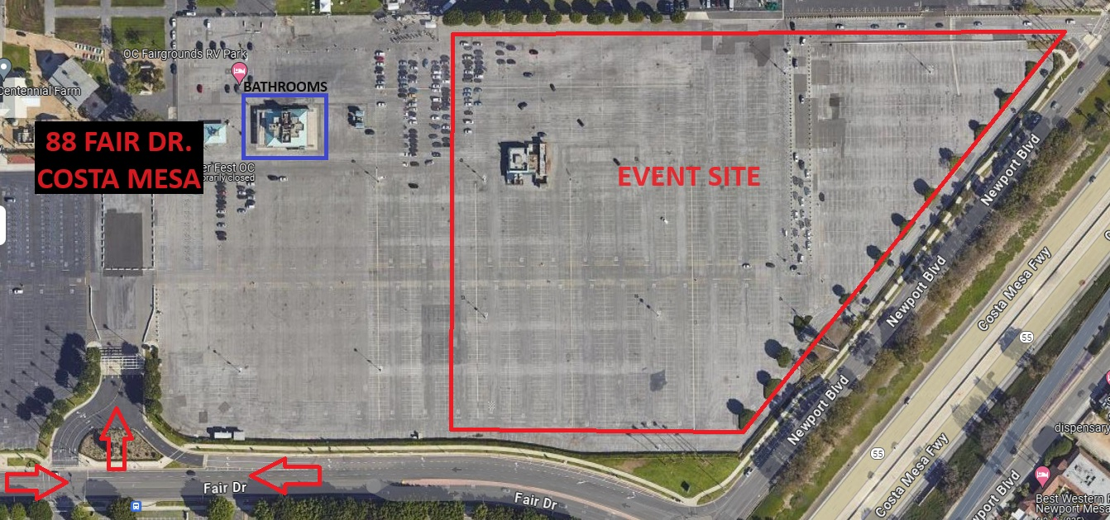
OPENING REMARKS:
Opening remarks will begin at 0715 hours. During the remarks we will go over the rules on the pad and discuss the patterns.

PATTERNS:
There will 15 rodeo-type patterns varying in difficulties. There will be a POST approved Motor Instructors assigned to each rodeo type pattern to assist those training. Brakes are okay to use on ALL rodeo-type patterns. All the patterns have been built and ridden to ensure that they can be successfully completed.
There will be 10 academy type patterns also available for those to warm-up on and qualify on if your department requires it. The high-speed patterns will not be included (40-Decel / 30- Cone Weave) for safety reasons.

LUNCH for ALL:
Lunch will be provided! We have been graced by volunteers from Santa Ana PD’s “31 Smokers” BBQ Pitmaster team!
Lunch will be served between 1130 and 1300. This is an opportunity to enjoy a delicious lunch prepared by the 31 Smokers team. We just ask that you donate to help recover the cost of the food that the association has covered for the event. There will be a collection jar and we will accept Venmo as well.

